Alec Viveros
Photoshop Basics for the “Editing the Planet” Project

*Upon taking your pictures*
Open “Photoshop”
Hit File->New
-Name your file the “project title” then your “last name”, so for this project mine would be named: “editingtheplanetViveros”.
-Make your canvas 11X17 with 300 resolutions; you can also make your canvas 17X11.

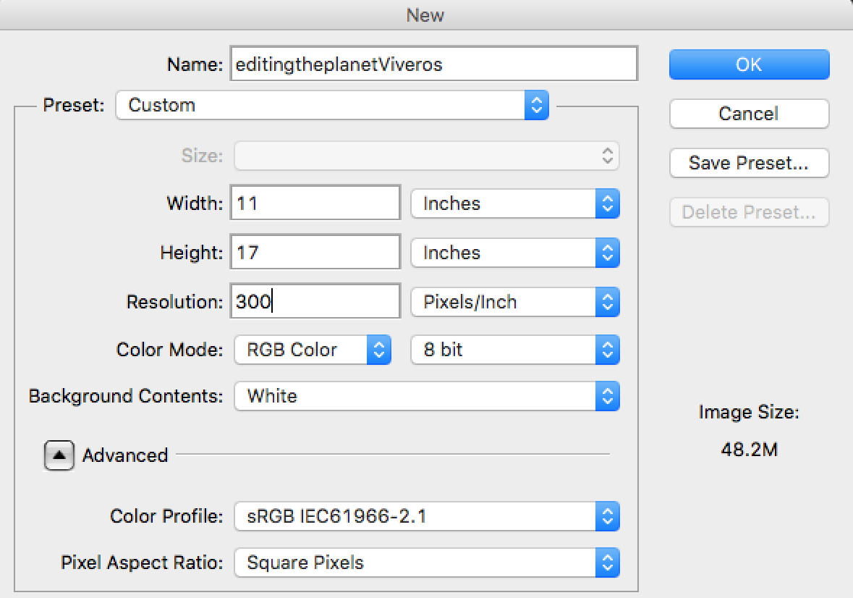

You will be editing your recyclables in a separate document.
Hit File->Open->Find the first picture you want to edit.
-We will be editing our pictures separately then collaging them on the final canvas using “Photoshop”.

*Simple Shortcuts*
Copy=Command+C
Paste=Command+V
Select and edit shape=Command+T
Deselect=Command+D

*Simple Photoshop Techniques*
Editing Color
Hit Image-> Adjustments
Here you will find many ways to edit the colors of your trash, play around with the different options.
Try This!
Hit->Adjustments->Replace Color
-Use the dropper tool and select the color you wish to change from your picture, in the result section you can chose which color you want it to be.

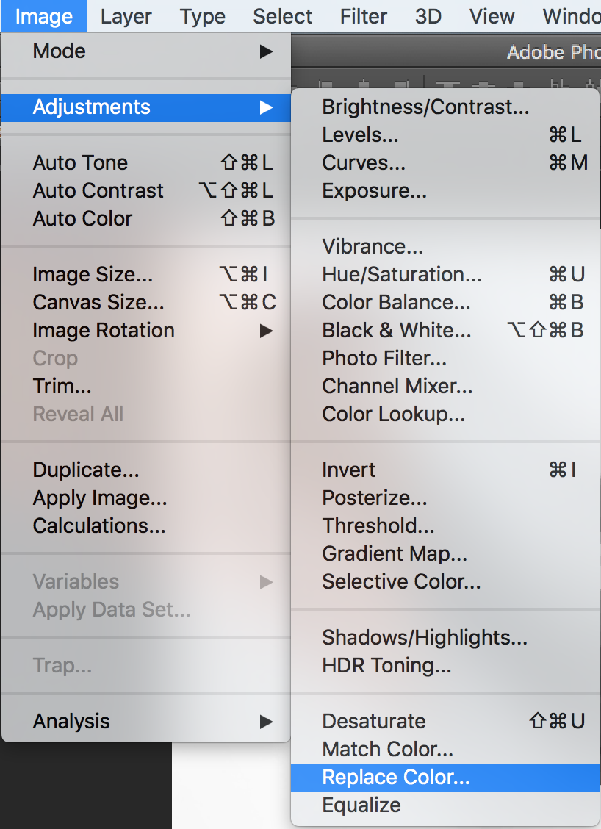

Using Filters
Hit Filter
Here you can apply many filters to your images of recyclables
Try This!
Hit Filter->Pixelate->Crystalize
-Drag the “Cell Size” arrow to alter the size of the crystals.

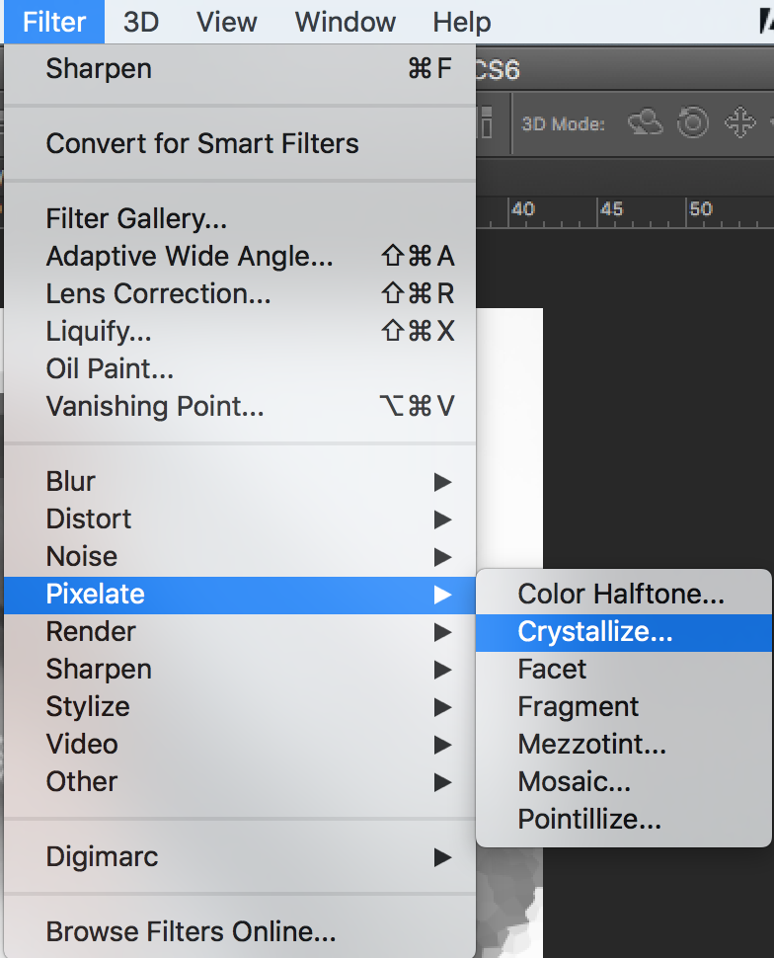

*When you are happy with how you edited your recyclable image*
-Use the “Lasso” tool to select the area you want to use, copy that area and paste it into the first “Photoshop” document we created.
-Continue editing the various photos you took and keep collaging them into your final canvas until you are happy with your results.

